**Failure and Immune reconstitution following HAART: A long term cohort in resource limited settings with viral load monitoring**

**Introduction**

There remains a paucity of data on the outcomes of long term ARV therapy cohorts in resource limited high Tuberculosis-burden settings including in, for example, Sub-Saharan Africa. In the data that is available a variety of prior studies have demonstrated that immunologic criteria have poor sensitivities and specificities for predicting virological oucomes. This has profound implications for HIV infected patients attending clinics in which routine virological monitoring is not available. These are due to the potential for unnecessary switches to 2nd or multiple line therapy along with the accumulation of resistance mutations, Aside from the individual impact there is also a decline in public health cost effectiveness in view of switches to more expensive ART and resistant patient care requirements.

In this study we present the outcomes of long term (5 year) HAART therapy in an as yet undescribed South African cohort in which both routine immunological and viral monitoring (i.e. minimally 6 monthly) was performed. In terms of outcomes we mean treatment failure as per WHO and per-protocol definitions, followed by immune recovery in those patients in whom viral suppression was successful following ARV therapy initiation. Immune recovery (i.e. gain in CD4 counts over time) was investigated in terms of ‘viral burden’ in a similar way to a recent methodology that was employed using first world data in which viral monitoring was more frequent than in our settings [Marconi et al]. We wished to determine if similar findings would be apparent in RL settings with less frequent viral load monitoring. We also examine the causality of the above outcomes additional to viral blip observations.

At a (near-future ?) date we also make the de-identified data available online for those researchers wishing to conduct additional or complementary analyses.

**Methods**

Study design and population

Lab procedures

Statistical Methods

All data were entered into a Microsoft Excel 2010 spreadsheet and descriptive statistics calculated.

Definitions

Failure:

* Per protocol
* CD4 failure by WHO 2010 criteria = Fall of CD4 count to baseline (or below) OR 50% fall from on-treatment peak value OR Persistent CD4 levels below 100 cells/mm3 (this is on page 50 Table12 of the 2010 WHO guidelines)

Viral suppression – a decrease of VL to the lower limit of detection (or to blip level ?) i.e. 50 copies/ml

• within < 6 months

• between 6 < 12 months

• between >12 < 60 months

Immune recovery:

• CD4 gained in < 24 months

• average individual CD4 during the period > 24 < 60 months

• total CD4 gained from the baseline

Definition/s of viral blips – VL between 50 and 400

Calculation of Positive and Negative predictive values

Regression modeling procedures

Data was then imported into Stata (SE version 12).

CD4 values were square root transformed to ensure distributional normality.

For (binary) failure outcomes – population based models in the form of robust GEE with time-dependent covariates (i.e. either viral load over time for immunological failure or CD4 over time for viral failure) specified with an autoregressive1 covariance matrix. i.e. the xtgee command in Stata

For (continuous) immune recovery outcomes linear regression (the regress command in Stata) was used.

Age, owing to *known* CD4 recovery dependency [ref?] and sex, owing to *known* adherence differences [ref?] were included by default. Our regression was *directed* in terms of using variables of clinical interest that were comparable to that defined by Marconi et al, rather than by selection procedures based on pure statistical criteria.

Statistical criteria that were used: Variables were excluded if their coefficient (β) was very small, i.e. with a confidence interval some distance away from a no-effect position (zero), and had a large p-value (i.e. > 0.1). Variables were retained if their p-value was small (i.e. < 0.1), or where the coefficient (β) was large (i.e. of great effect).

In that the above models were defined using cohort rather than RCT data they were predictive rather than causal in a nature and an overall *variable-inclusive* strategy was followed. For the same reason we do not present exhaustive goodness-of-fit model diagnostic results.

Could look at residuals and also the ‘predict’ function to draw curves by CD4 initiation category…..

**Results:**

Table 1. Characteristics of patients on HAART studied (Cari, please check these)

|  |  |  |  |  |
| --- | --- | --- | --- | --- |
| Category | Variable/Group | group | Na (%) | mean (stdev) |
| Demographics/ | All |  | 854 (100.0) |  |
| clinical issues: | sex | male | 263 (30.8) |  |
|  |  | female | 589 (69.0) |  |
|  | age groups | 0-29 | 170 (19.9) |  |
|  |  | 30-39 | 387 (45.3) |  |
|  |  | 40-49 | 197 (23.1) |  |
|  |  | 50+ | 98 (11.5) |  |
|  | WHO disease stage | 1 | 25 (2.9) |  |
|  | (at baseline) | 2 | 93 (10.9) |  |
|  |  | 3 | 441 (51.6) |  |
|  |  | 4 | 222 (26.0) |  |
|  | BMI - body mass index |  | 659 (77.2) | 22.4 (9.1) |
|  | BMI < 18 |  | 113 (13.2) |  |
|  | BMI > 18 |  | 546 (63.9) |  |
|  | employed | No | 552 (64.6) |  |
|  |  | Yes | 222 (26.0) |  |
|  | distance travelled - to clinic from home | 0-20 | 311 (36.4) |  |
|  |  | 21-40 | 433 (50.7) |  |
|  |  | 41-60 | 32 (3.8) |  |
|  |  | 60+ | 24 (2.8) |  |
|  | LTFUP - lost to follow up | No | 773 (90.5) |  |
|  |  | Yes | 75 (8.8) |  |
|  | Died | No | 703 (82.3) |  |
|  |  | Yes | 61 (7.1) |  |
| Adherence | Regimen_change - of any sort | No | 423 (49.5) |  |
| Issues: |  | Yes | 427 (50.0) |  |
|  | Interruption - of ART for short duration | No | 673 (78.8) |  |
|  |  | Yes | 138 (16.2) |  |
|  | Stopped - ART permanently | No | 813 (95.2) |  |
|  |  | Yes | 27 (3.2) |  |
|  | Side effects - of ART | No | 272 (31.9) |  |
|  |  | Yes | 582 (68.1) |  |
|  | Comorbidity - at baseline | None | 303 (35.5) |  |
|  |  | TB | 257 (30.1) |  |
|  |  | Others | 294 (34.4) |  |
|  | Defaulted - no clinic visit for > 3 months | No | 739 (86.5) |  |
|  |  | Yes | 110 (12.9) |  |
|  | Non-adherent - by self report | No | 735 (86.1) |  |
|  |  | Yes | 112 (13.1) |  |
|  | Transferred_in - from another centre during | No | 715 (83.7) |  |
|  | the ART duration | Yes | 135 (15.8) |  |
| Biomarkers: | CD4_baseline |  | 833 (97.5) | 98.9 (85.0) |
|  | Baseline CD4 < 50 |  | 276 (32.3) |  |
|  | Baseline CD4 51 <100 |  | 190 (22.3) |  |
|  | Baseline CD4 101 < 150 |  | 178 (20.8) |  |
|  | Baseline CD4 151 < 200 |  | 140 (16.4) |  |
|  | Baseline CD4 > 200 |  | 49 (5.7) |  |
|  | logVL_baseline |  | 797 (93.3) | 5.031 (0.750) |
|  | Baseline VL < 100000 |  | 346 (40.5) |  |
|  | Baseline VL > 100000 |  | 451 (52.8) |  |
|  | Viral blips |  | 167 (19.6) |  |
| Failures | VL>400, @ any 1 point > 6 months |  | 242 (28.3) |  |
|  | VL>400, @ any 2 consecutive points > 6 months |  | 85 (10) |  |
|  | VL>1000, @ any 2 consecutive points > 6 months |  | 66 (7.7) |  |
|  | VL>5000, @ any 2 consecutive points > 6 months |  | 52 (6.1) |  |
|  | ‘CD4-failure’ according to WHO criteria |  | 149 (20.0) |  |
| Viral suppression | within < 6 months |  | () |  |
|  | between 6 < 12 months |  | () |  |
|  | between >12 < 60 months |  | () |  |
|  | never suppressed |  |  |  |
| Immune-recovery | CD4 gained in < 24 months**** |  | 533 (64.0) | 284.6 (109.0) |
|  | average individual CD4 during the period > 24 < 60 months |  | *1035 (100)?? | 453.6 (217.1) |
|  | total CD4 gained from the baseline |  |  | 295.2 (157.1) |

|  |  |  |
| --- | --- | --- |
| **Row Labels** | **Count of PT_NUMBER** |  |
| het ni suppress | 48 | 5.6% |
| 0-6 | 599 | 70.1% |
| 6-12 | 62 | 7.3% |
| 12-60 | 41 | 4.8% |
|  | 104 | 12.2% |
| **Grand Total** | **854** |  |

Notes:

Na (%)= number and percentage of *instances, or subjects, for whom data was available in total to the respective time point.

CAT = category

‘Baseline’ is the point at which ART was initiated

* Explain (Martin) - the variables under biomarkers – e.g. viral blips

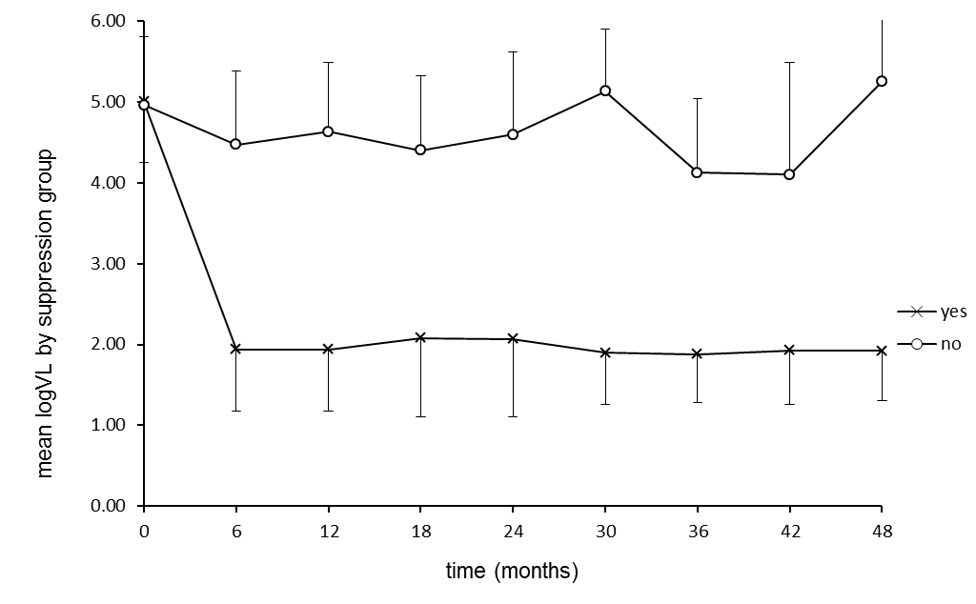

**Figure 1.** Average log Viral Load (VL) for patients who did or did not suppress the virus to < 400 copies/ml (2.6 log) at any time during the 5 years of therapy. In the vast majority of patients (684/(781) = 87.6 %) VL was suppressed within the first 12 months of therapy.

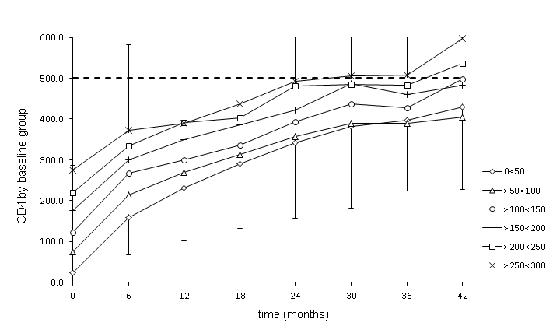

**Figure 2.** Average CD4 (+) cell count recovery stratified by baseline category, following initiation of HAART.Although deviations were large, groups tended to increase in parallel lines. This was true for all patients, whether they experienced viral failure or not. (This sort of pattern has been observed before, by Gras et al 2008, and by the Iedea consortium. It means that your long term recovery is determined by your starting value)

Notes:

1. In the groups with baseline CD4 below 200 cells/mm3 there was a mean of 196 per group (max 276 - min 140) while above 200 only a total of 47. This was obviously due to the therapy initiation criteria
2. In the groups with baseline CD4 below 200 cells/mm3, only 30.0 % of patients ever reached a maximum CD4 count of 500 (i.e. ‘complete immunological recovery’) in the 5 year course of therapy. Above 200, 70.0% reached 500.
3. The > 300 group was excluded since this was a very small group, starting with only 12 individuals and with very large deviations in values. Only data to 42 months included since only data for < 40 patients were available above this

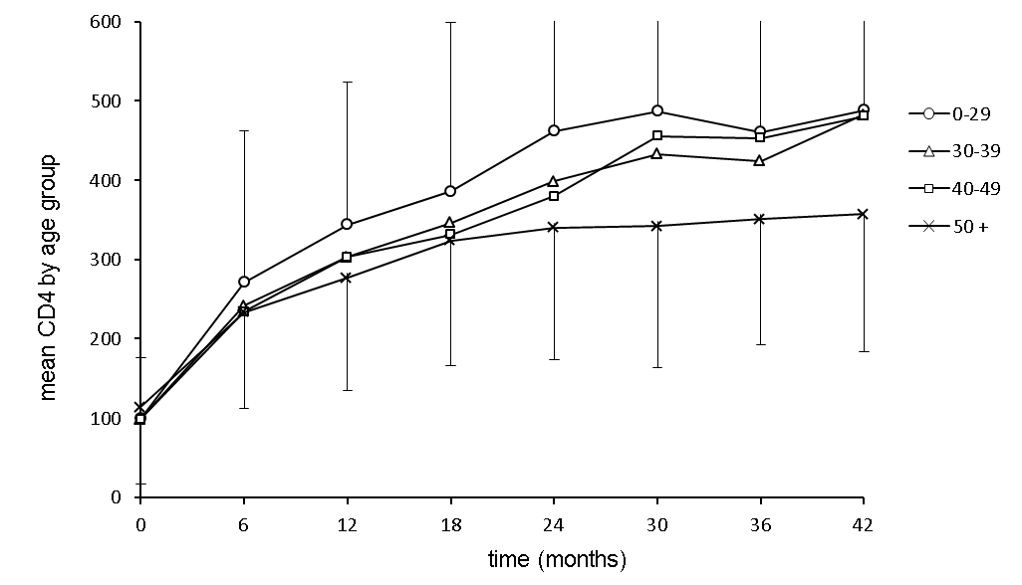

**Figure 3.** Average CD4 (+) cell count recovery stratified by age, for those who suppressed the virus to < 400 copies/ml within 12 months...

CARI: CD4 recovery is known to be determined by age and we included Age_continuous by default. Do you think we need to look at the models with age categories too? It doesn’t seem to me to be at the core of our research questions…..

## Predictive values of CD4 failure for VL failure

i.e. those who would have been misclassified had there been no VL testing available

. tab ORabcANY VL400ANY

| VL400ANY

ORabcANY | 0 1 | Total

-----------+----------------------+----------

0 | 448 147 | 595

1 | 57 91 | 148

-----------+----------------------+----------

Total | 505 238 | 743

**PPV = 91/148= 61.5%**

**NPV = 448/595= 75.3%**

. tab ORabcANY consec400ANY

| consec400ANY

ORabcANY | 0 1 | Total

-----------+----------------------+----------

0 | 498 45 | 543

1 | 95 40 | 135

-----------+----------------------+----------

Total | 593 85 | 678

**PPV=40/135= 29.6%**

**NPV=498/543= 91.7%**

. tab ORabcANY consec1000ANY

| consec1000ANY

ORabcANY | 0 1 | Total

-----------+----------------------+----------

0 | 512 31 | 543

1 | 100 35 | 135

-----------+----------------------+----------

Total | 612 66 | 678

**PPV=35/135= 25.9%**

**NPV=512/543= 94.3%**

. tab ORabcANY consec5000ANY

| consec5000ANY

ORabcANY | 0 1 | Total

-----------+----------------------+----------

0 | 522 21 | 543

1 | 104 31 | 135

-----------+----------------------+----------

Total | 626 52 | 678

**PPV=31/135= 23%**

**NPV=522/543= 96.1%**

## Predictive values of failures for death

. tab ORabcANY death

| death

ORabcANY | 0 1 | Total

-----------+----------------------+----------

0 | 547 11 | 558

1 | 134 5 | 139

-----------+----------------------+----------

Total | 681 16 | 697

**PPV=5/139= 3.6%**

**NPV= 547/558 = 98.0%**

tab VL400ANY death

| death

VL400ANY | 0 1 | Total

-----------+----------------------+----------

0 | 470 9 | 479

1 | 213 10 | 223

-----------+----------------------+----------

Total | 683 19 | 702

**PPV = 10/223 = 4.5**

**NPV = 470/479 = 98.1**

. tab consec400ANY death

consec400A | death

NY | 0 1 | Total

-----------+----------------------+----------

0 | 567 5 | 572

1 | 77 4 | 81

-----------+----------------------+----------

Total | 644 9 | 653

**PPV = 4/81 = 4.9**

**NPV = 567/572 = 99.1**

. tab consec1000ANY death

consec1000 | death

ANY | 0 1 | Total

-----------+----------------------+----------

0 | 582 8 | 590

1 | 62 1 | 63

-----------+----------------------+----------

Total | 644 9 | 653

**PPV = 1/63 = 1.6**

**NPV = 582/590 = 98.6**

. tab consec5000ANY death

consec5000 | death

ANY | 0 1 | Total

-----------+----------------------+----------

0 | 596 8 | 604

1 | 48 1 | 49

-----------+----------------------+----------

Total | 644 9 | 653

**PPV = 1/49 = 2.04**

**NPV = 596/604 = 98.7**

i.e. Death and Failure have no discernible relationship

**Predictive values of VL blips for failure**

. tab any_blip VL400ANY

| VL400ANY

any_blip | 0 1 | Total

-----------+----------------------+----------

0 | 347 161 | 508

1 | 95 54 | 149

-----------+----------------------+----------

Total | 442 215 | 657

**PPV = 54/149 = 36.2**

**NPV = 347/508 = 68.3**

. tab any_blip consec400ANY

| consec400ANY

any_blip | 0 1 | Total

-----------+----------------------+----------

0 | 408 56 | 464

1 | 119 16 | 135

-----------+----------------------+----------

Total | 527 72 | 599

**PPV = 16/135 = 11.9**

**NPV = 408/464 = 87.9**

. tab any_blip consec1000ANY

| consec1000ANY

any_blip | 0 1 | Total

-----------+----------------------+----------

0 | 420 44 | 464

1 | 123 12 | 135

-----------+----------------------+----------

Total | 543 56 | 599

**PPV = 12/135 = 8.9**

**NPV = 420/464 = 90.5**

. tab any_blip consec5000ANY

| consec5000ANY

any_blip | 0 1 | Total

-----------+----------------------+----------

0 | 431 33 | 464

1 | 126 9 | 135

-----------+----------------------+----------

Total | 557 42 | 599

**PPV = 9/135 = 6.7**

**NPV = 431/464 = 92.9**

. tab any_blip ORabcANY

| ORabcANY

any_blip | 0 1 | Total

-----------+----------------------+----------

0 | 408 99 | 507

1 | 111 36 | 147

-----------+----------------------+----------

Total | 519 135 | 654

**PPV = 36/147 = 24.5**

**NPV = 408/507 = 80.5**

**Variable dependencies (and thus selection/exclusion) for the Adherence_issues part of the Failure Models below**

. tab interrupted side_effects, row chi2

interrupte | side_effects

d | 0 1 | Total

-----------+----------------------+----------

n | 231 442 | 673

| 34.32 65.68 | 100.00

-----------+----------------------+----------

y | 20 118 | 138

| 14.49 85.51 | 100.00

-----------+----------------------+----------

Total | 251 560 | 811

| 30.95 69.05 | 100.00

Pearson chi2(1) = 21.0741 Pr = 0.000

85.51% of everyone who interrupted, interrupted due to side-effects…

. tab change side_effects, row chi2

| side_effects

change | 0 1 | Total

-----------+----------------------+----------

n | 220 204 | 424

| 51.89 48.11 | 100.00

-----------+----------------------+----------

y | 50 376 | 426

| 11.74 88.26 | 100.00

-----------+----------------------+----------

Total | 270 580 | 850

| 31.76 68.24 | 100.00

Pearson chi2(1) = 158.0401 Pr = 0.000

88.26% of everyone who changed regimen, changed due to side-effects…

Two variables very correlated with side-effects: **my suggestion is to leave out side-effects as a predictor.**

Changed and interrupted are not correlated >

| interrupted

change | n y | Total

-----------+----------------------+----------

n | 331 66 | 397

| 83.38 16.62 | 100.00

-----------+----------------------+----------

y | 340 72 | 412

| 82.52 17.48 | 100.00

-----------+----------------------+----------

Total | 671 138 | 809

| 82.94 17.06 | 100.00

Pearson chi2(1) = 0.1035 Pr = 0.748

Stopped and defaulter:

. tab stopped defaulter, chi2 row

| defaulter

stopped | n y | Total

-----------+----------------------+----------

n | 721 91 | 812

| 88.79 11.21 | 100.00

-----------+----------------------+----------

y | 8 19 | 27

| 29.63 70.37 | 100.00

-----------+----------------------+----------

Total | 729 110 | 839

| 86.89 13.11 | 100.00

Pearson chi2(1) = 80.2914 Pr = 0.000

Very few stopped, so maybe not important.

Non-adherer and defaulter:

tab Nonadherer defaulter, chi2 row

| defaulter

Nonadherer | n y | Total

-----------+----------------------+----------

n | 689 46 | 735

| 93.74 6.26 | 100.00

-----------+----------------------+----------

y | 49 63 | 112

| 43.75 56.25 | 100.00

-----------+----------------------+----------

Total | 738 109 | 847

| 87.13 12.87 | 100.00

Pearson chi2(1) = 216.6198 Pr = 0.000

Or, maybe more intuitively, the other way round:

tab Nonadherer defaulter, chi2 col

| defaulter

Nonadherer | n y | Total

-----------+----------------------+----------

n | 689 46 | 735

| 93.36 42.20 | 86.78

-----------+----------------------+----------

y | 49 63 | 112

| 6.64 57.80 | 13.22

-----------+----------------------+----------

Total | 738 109 | 847

| 100.00 100.00 | 100.00

Pearson chi2(1) = 216.6198 Pr = 0.000

So 93% of those who didn’t default were adherent…

Or, even more descriptive: in 689 of the 847 cases (81%) for which we have information on both adherence and defaulting, they were the same…

**Defaulting was observed by the clinician and was for 3 months or longer**

**Nonadherer was self reported and could have been for even one day.**

**CARI: As per discussion will you please check if the BMI categories, i.e. < 18 or > 18 are meaningful in our failure models?**

**Table 2. HAART treatment failure models**

|  |  |  |  |  |  |  |
| --- | --- | --- | --- | --- | --- | --- |
| **Model/s** |  | **Failure Outcome** | | | | |
|  |  | VL>400, @ any point on > 6 months | VL>400, @ any 2 consecutive points  > 6 months | VL>1000, @ any 2 consecutive points  > 6 months | VL>5000, @ any 2 consecutive points > 6 months | *CD4 failure according to WHO criteria |
|  | **Na: patients** | 397 | 486 | 486 | 480 | 487 |
|  | **N: observations**  **ave. observations/patient** | 2083  5.2 | 2667  5.5 | 2667  5.5 | 2647  5.5 | 2835  5.3 |
| **Predictor:**  **(β with 0.95 C.I.)** | **age (continuous)** | -0.013  (-0.036 and 0.009) | -0.020  (-0.060 and 0.015) | -0.018  (-0.057 and 0.020) | -0.014  (-0.056 and 0.028) | 0.028  (0.003 and 0.053) |
|  | **sex (1 =female)** | -0.025  (-0.468 and 0.417) | 0.282  (-0.361 and 0.925) | 0.265  (-0.426 and 0.956) | 0.292  (-0.463 and 1.048) | -0.217  (-0.699 and 0.265) |
|  | **BMI** | -0.050  (-0.098 and -0.002) |  |  |  |  |
| **Viral or immune indicators** | **VL_not suppressed at 12 months** |  | 2.755  (2.125 and 3.384) | 2.665  (1.974 and 3.355) | 2.651  (1.887 and 3.416) | 1.3788  (0.844 and 1.914) |
|  | **logVL over time** | NA | NA | NA | NA | 0.064  (-0.062 and 0.190) |
|  | **sqrt_CD4 over time** | -0.074  (-0.104 and -0.044) | -0.089  (-0.139 and -0.039) | -0.110  (-0.166 and -0.054) | -0.127  (-0.192 and -0.063) | NA |
|  | **baseline_CD4 stratum (<200 and >200)** |  |  |  |  | 0.945  (0.226 and 1.664) |
| **Adherence issues** | **non-adherent** | 1.102  (0.566 and 1.638) | 1.509  (0.857 and 2.161) | 1.648  (0.958 and 2.338) | 2.048  (1.236 and 2.860) | 0.994  (0.341 and 1.647) |
|  | **transferred-in** | -0.576  (-1.167 and 0.015) | -1.701  (-3.338 and -0.064) | -1.480  (-3.126 and 0.165) | -2.039  (-4.355 and 0.277) |  |
|  | **changed regimen** | 0.493  (0.084 and 0.903) |  |  |  |  |
|  | **interrupted** | 1.107  (0.595 and 1.618) |  |  |  |  |
|  | **defaulted** |  |  |  | -0.958  (-2.122 and 0.206) | 0.826  (0.048 and 1.605) |
|  | **stopped** | 0.890  (-1.111 and 1.891) |  |  | 1.066  (-0.557 and 2.689) |  |
|  | **intercept (β0)** | -0.287  (-1.628 and 1.054) | -2.790  (-4.395 and -1.184) | -2.836  (-4.587 and -1.084) | -3.091  (-5.016 and -1.167) | -4.715  (-5.874 and -3.557) |

Notes:

* *CD4 failure according to WHO criteria = Fall of CD4 count to baseline (or below) OR 50% fall from on-treatment peak value OR Persistent CD4 levels below 100 cells/mm3 (this is on page 50 Table12 of the 2010 WHO guidelines)
* Variables were excluded if their coefficient (β) was very small, i.e. of little effect on the outcome, and had a large p-value (i.e. > 0.1).
* Variable were retained if p-value was small (i.e. < 0.1), or where the coefficient (β) was large (i.e. of great effect)
* Age (because of *known* CD4 recovery dependency) and sex (because of *known* adherence differences) were included a priori.
* All (xtgee) models converged within < 6 iterations and had overall p values of < 0.01.
* We had ‘per protocol’ and WHO definitions of viral failure

|  |  |  |  |  |  |  |  |
| --- | --- | --- | --- | --- | --- | --- | --- |
| **Model/s** |  | **Recovery Outcome** | | | | | |
|  |  | Yearly sqrt_CD4 gain in first 24 months | Yearly sqrt_CD4 gain in first 24 months | mean sqrt_CD4 after 24 months | mean sqrt_CD4 after 24 months | total sqrt_CD4 gain from baseline | total sqrt_CD4 gain from baseline |
|  | **N (patients)** | 463 | 465 | 481 | 483 | 603 | 655 |
| **independent variable:**  **(β with 0.95 C.I.)** | **age (continuous)** | -0.038  (-0.062 ; -0.014) | -.039  (-.063 ; -0.015) | -0.072  (-0.119 ; -0.025) | -0.068  (-0.114 ; -0.021) | -0.086  (-0.129 ; -0.043) | -0.073  (-0.115 ; -0.032) |
|  | **sex (1=female)** | 0.727  (0.256 ; 1.198) | 0.810  (0.342 ; 1.277) | 1.891  (0.987 ; 2.796) | 1.925  (1.035 ; 2.816) | 1.844  (1.302 ; 2.655) | 1.445  (0.677 ; 2.233) |
|  | **sqrt CD4 _baseline value** | -0.363  (-0.421 ; -0.306) | -0.357  (-0.414 ; -0.300) | 0.234  (0.124 ; 0.343) | 0.239  (0.131 ; 0.346) | -0.730  (-0.823 ; -0.633) | -0.664  (-0.755 ; -0.573) |
|  | **VL slope in 1st 12 months** | -0.316  (-0.559; -0.072) | NA | -0.340  (-0.804 ; 0.125) | NA | -0.501  (-0.896 ; -0.107) | NA |
|  | **total viral burden** | NA | -0.142  (-0.239 ; -0.044) | NA | -0.294  (-0.475 ; -0.114) | NA | -0.593  (-0.716 ; -0.469) |
|  | **VL_suppressed at 6 months** | 2.435  (0.265 ; 4.605) | 2.686  (0.329 ; 5.043) | 7.409  (3.176 ; 11.642) | 7.520  (2.961 ; 12.080) | 7.371  (5.216 ; 9.526) | 3.668  ( 1.828 ; 5.507) |
|  | **VL_suppressed at 12 months** | 1.929  (-0.350 ; 4.208) | 2.745  (0.242 ; 5.249) | 6.501  (2.068 ; 10.934) | 7.689  (2.865 ; 12.514) | 6.656  (4.150 ; 9.162) | 4.422  (2.063 ; 6.782) |
|  | **VL_suppressed after 12 months** | 0.865  (-1.583 ; 3.313) | 1.431  (-1.160 ; 4.023) | 5.279  (0.583 ; 9.974) | 7.064  (2.101 ; 12.026) | 6.714  (3.878 ; 9.549) | 6.181  (3.667 ; 8.694) |
|  | **Intercept (β0)** | 5.811  (3.533 ; 8.089) | 7.362  (4.715 ; 10.008) | 10.646  (6.207 ; 15.086) | 13.224  (8.125 ; 18.322) | 11.654  (9.171 ; 14.138) | 19.889  (16.957 ; 22.821) |

**Table 3. HAART immune-recovery models**

Note: These models are only for patients that successfully suppressed the virus at any point (i.e.VL_suppr= 0, if not suppressed) and which had data with no gaps in it.

This is not true. It is only for those people who we KNOW suppressed OR NOT. “Not suppressed” is the baseline category.

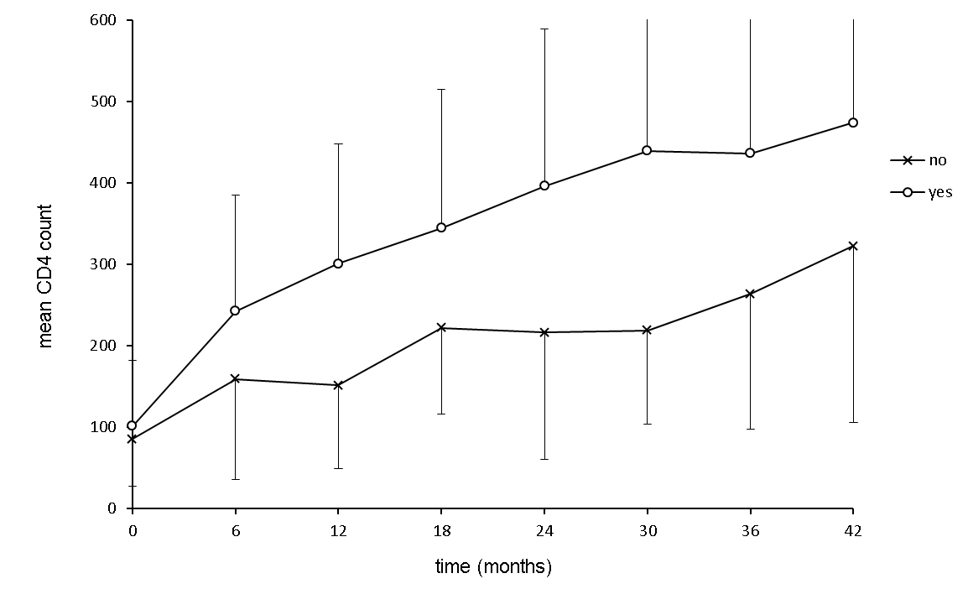

**Figure 3.** Graph of mean CD4 counts categorised by VL suppression within < 12 months. All patients demonstrated improvements in CD4 count following initiation of HAART. However, on average, patients that were unable to suppress the virus within 12 months or less did not recover CD4 counts as effectively as those that did.

Note: Data has been constrained to a minimum of >10 patients per point.